Zombo Joe
kill zombies and stuff

Summary
Zombo Joe is a game about love. The love of killing hordes of zombies. The player assumes the role of the character Joe, an American Vietnam vet who became a janitor after the war. The war never really ended for Joe, though, and he’s been steadily building up a stockpile of home-made weapons and devices ever since he “retired”.
As Joe, the player must fight off wave after wave of zombies in a variety of environments and situations. Through a 3rd person perspective, Joe must make use of his weapons, environment, and his own MacGuyver-esque ingenuity to dispatch hundreds of zombies at a time. The player has the ability to manipulate many of the objects in any level to route zombies into traps or construct safe zones for Joe to fire from.
From explosive propane tanks, to half-collapsed buildings, to exposed gas mains below a city street, the world is your weapon. In addition to the endless ways which the player can leverage his environment to kill off zombies, Joe will have many different weapons at his disposal as well. His basic weapons are his machete from Nam and the M79 grenade launcher he used to kill Charlie so many times. As the game progresses, Joe can gain access to a wide array of other weapons, from standard weapons like a pistol and sniper rifle, to more interesting tools such as a top-secret military freeze gun and a saw-blade-firing crossbow (great for multiple decapitations).
With all these tools at his disposal, the player can play the same mission 20 times and find a different way to beat it each time. The tactics available to the player can change from mission to mission; some will be simple “plant and defend” situations where Joe must fortify a location and fend off wave after wave of zombies. He’ll be sent on rescue missions where he’ll have to fight his way though seas of zombies to save people or vital equipment, or escort a group of people through zombie-infested territory. Every mission will be as open-ended as possible, allowing the player to solve the problem their own way.
WRITE MORE HERE

Background
Nobody knows much about Joe, except that he’s a war vet and is pretty sketchy if you try to talk to him about anything besides cleaning toilets or taxidermy. When the zombies showed up, he immediately reverted to war mode, and became the only person in Townsville capable of fending off the zombie hordes.
The details on the zombie war are vague at first, and the player never really get the complete picture of what’s going on, where the zombies came from, or how the rest of the world is handling it. The military is the only organization left capable of long-range communication, and they’re outposts are quickly being overrun. Joe ends up being one of the key characters in an effort to create a small “safe zone” for refugees and soldiers like himself.
Once established, this safe zone will act as Joe’s base of operations for the rest of the game. He’ll meet NPCs here that will send him on missions and give him access to new weapons and tools.
WRITE MORE HERE

Gameplay

POINT SYSTEM – the universal language
(note: numerical values in this section certain to change with play testing)
Zombo Joe’s built-in incentive to kill creatively is its point system. The player earns points by doing pretty much anything, but they won’t start earning significant amounts of points without finding ways to kill many, many zombies at once.
Each zombie is worth a set number of points. Shoot a zombie in the head, kill it, get points. Blow a zombie up by detonating a propane tank, get a 2x multiplier on that zombie. Kill 5 zombies with one propane tank, get a 5x multiplier on those points. 10 zombies, 10x the points. If another object is used to kill the zombies, that also adds a multiplier. For example, if the player stacks debris (desks, scrap metal, etc) around a propane tank, then detonates the tank, the debris will shoot out like shrapnel from a grenade. If one flaming piece of debris takes out 3 zombies, you get a bonus multiplier from the propane tank, the flying debris, and the number of zombies killed with one shot, plus a multiplier based on how many zombies are killed by the other pieces of debris.
There are way too many ways to kill zombies for me to list them all at this points, but we are trying to build a system that will be able to reward a player appropriately even if they manage to come up with a way to kill zombies that we didn’t. The point system is a framework that the game works within.
The second half of the point system is what the player can actually do with their points once they’re earned them. Points are Zombo Joe’s universal currency. We’ll probably have to find a better name than “points”, but for the sake of this ddoc, pretend that “points” sounds like a perfectly legitimate form of currency.
Once earned, the player can spend these points in a variety of ways at their home base. While back at camp, the player can purchase ammo, equipment, weapon upgrades, and new abilities from NPCs. The specifics of what the player can buy are detailed in the TOOLS section of the ddoc. Only certain things will be available at first, but more will become available as the player completes missions and befriends new NPCs. For example, complete a mission for the military, and you gain access to some new military-grade hardware. Complete another couple of missions and unlock some higher level gear. Each NPC will have their own theme-appropriate upgrades and tools available for purchase as the game progresses.
Joe will also be able to pick up new items and weapons while playing through levels, but many of the game’s items will only be available through certain NPCs.

THE ENVIRONMENT – Not just for hippies anymore!
One of the key gameplay elements that makes Zombo Joe unique is the ability to alter the level environments in ways that better serve the player’s tactics. In many levels, Joe will have time on his side, with the zombies closing in from a distance. Sometimes he’ll have as much time as he wants, others he’ll only have a couple of minutes. Scattered throughout the levels will be piles of debris and junk, left over from people trying to fend off the zombies on their own. Cars have crashed into buildings, buildings have crumbled, planes have crashed, trains derailed. Joe always had unnatural strength, and is able to pick up and move anything up to a certain size (one upgrade that can be bought is physical training, allowing Joe to lift larger objects).
Some objects can be used as barriers, platforms, or simply stacked up to give Joe some higher ground to shoot from. Zombo Joe will have a complex physics system, allowing the player to essentially build zombie death machines if they feel like it. For example, the player places a chunk of concrete on the ground. Then, he places a wood palette on it so it sits at an angle, and puts a propane tank on top. Next, they drop a few chunks of concrete and metal scraps in front of the propane tank, aimed towards the zombies. With a gun in hand to detonate the propane tank, the player has just built a huge propane-powered shrapnel shotgun.
The player can also place objects around the environment to force the zombies’ path in a specific direction, such as over a cliff or into a series of traps (like the afore-mentioned shrapnel gun).
Many levels will also include semi-scripted zombie mutilation tools, such as a conveniently crashed jumbo jet that just happens to have its still-running jet engine intake sitting nearby the zombies’ path. Other semi-scripted tools include, but are not limited to:
- A building on the brink of collapse that, with the help of a propane tank or two, could easily crush 100 zombies in the street outside.
- An exposed natural gas main just begging to be lit by a stray bullet.
- A military air-strike.
- A stone bridge with some rather large cracks down the middle,
- A crane with attached wrecking ball controllable by the player.
- A crashed gas tanker semi.
- A crashed helicopter with blades still spinning, right around zombie-height.
- Blah blah more stuff blah

There’s more stuff to write about this… I’ll get back to it.

TOOLS
Weapons
Joe will have access to many different weapons throughout the course of the game, all with different functions and purposes. Many weapons also have a secondary function, detailed below.

- Machete: Joe’s machete from Nam, it’s super sharp and he knows how to handle it. He starts the game with it, and normally holds it upright in his right hand.
Secondary: Joe flips the blade around so he’s holding it upside down and the blade is pointing down and back. Same amount of damage, but extra style multiplier points for switching between the two modes while slicing up zombies.
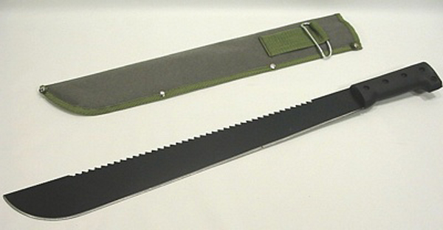

- M79 Grenade Launcher: Joe’s other weapon from Nam, his trusty Thump Gun. Joe’s other starting weapon, he can fire it like a mortar, or like a shotgun. All ammo types work in both modes, but most of designed for one or the other. In mortar mode, the targeting sight shows the arc the mortar will take, and where it will land. Joe starts the game with 2 ammo types available: Explosive Round (standard mortar) and Scatter Shot (powerful shotgun)
Secondary: The target sight changes to standard crosshair-style, and Joe repositions the gun to hold it more like a shotgun.
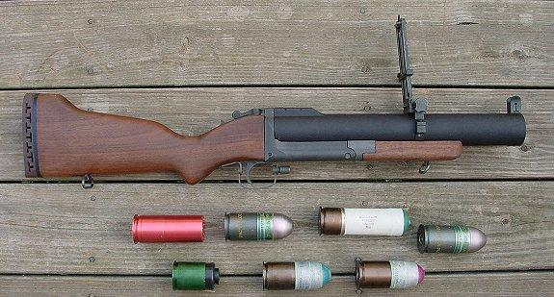
- Saw Blade Crossbow: An awesome homemade decapitator, the saw blade crossbow uses an electric motor to spin saw blades and then fire them like death Frisbees. If you catch a zombie just right in the neck with one, it’ll cut all the way through and continue on to the next zombie. Joe claims to have felled 5 zombies once with one blade.
Secondary: None
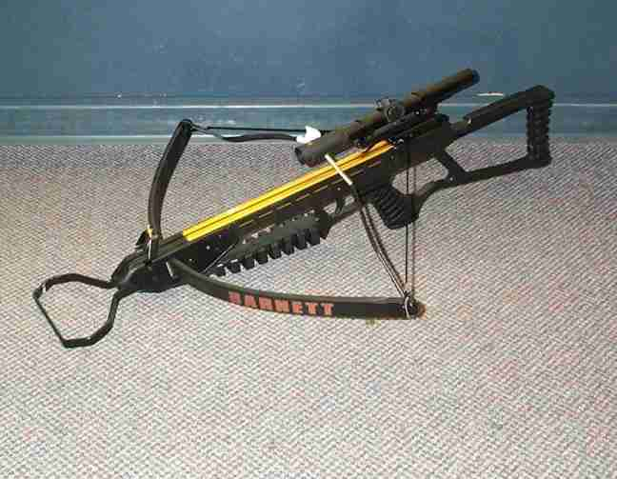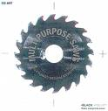
- Sniper Rifle: The classic weapon returns, and will be tons of fun to use with all the different ammo types, in addition to being good for detonating distant explosives.
Secondary: Toggles between zoom levels (5x, 10x)
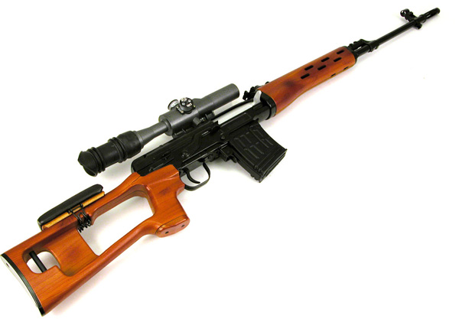
- Flame Thrower: This homemade flamethrower is one of Joe’s favorite weapons. While he never got to use one in Nam, he saw them a lot and developed a bit of a fetish. He’s built several versions and has honed his design into the weapon he uses in game. This weapon is not immediately available, the player must retrieve it from Joe’s zombie-overrun house during a mission.
Secondary: Toggles between normal (flame shooting mode) and passive (sprays unlit fuel) firing modes.
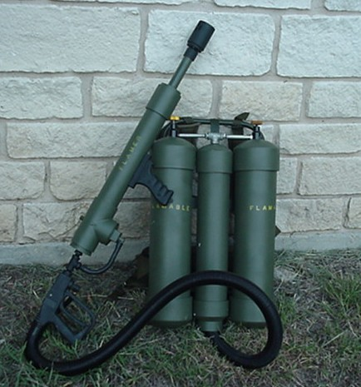
- More pls

Ammo
Certain guns can use multiple types of ammo. I’ll add more details later about which gun uses what.

- Standard: Regular bullet, kills a zombie if fired at their head. Causes 1 out of every 5 heads shot to explode.
- Scatter: Shotgun-type round
- Incendiary: Explodes after impact, blows a zombie apart if shot into chest, blows head up if shot into head. When shot, zombie starts to emit faint red glow about 1 second, then explodes. If shot in the head, the eyes glow bright red during this time.
- Remote Detonation: Doesn’t explode on impact, just lodges itself in the victim until the player hits the secondary fire and detonates all unexploded remote bullets (can have 5? Bullets stuck in zombies at a time)
- Fragmentary: Explodes on impact like a grenade. Similar effect to incendiary, with small chunks of metal that have a chance to hit and kill (or maim) zombies nearby.
- Remote Detonation Fragmentary. Fragmentary bullet that can be detonated like the Remote Detonation bullet.
- Bad Blood Bullet: Shoot this bullet into the brain of a zombie, and it goes berserk and starts to attack the other zombies until they kill it. Good way to buy a little time, as most of the zombies will focus on these corrupted zombies before turning back on Joe.
- Armor Piercing: Can pass through up to 5 exploding zombie heads before stopping, if lined up right.

Explosives
There are several different kinds of explosives available to Joe throughout the game. Some can be purchased at camp, others can only be found within certain missions.
Note: When a zombie catches on fire, it will start wandering aimlessly and flail about, sometimes catching other zombies on fire.

- Propane Tank: The bread and butter of explosives, the propane tank provides a solid, medium sized explosion with no shrapnel and a good strength shockwave. It’ll blow apart any zombies that are standing within a few feet of it, and knock over any within 20 feet. Can be bought in camps and found scattered throughout the game.
- Spray Paint: The spray cans are Joe’s home-made grenades. Cheap to buy at camp and occasionally plentiful during certain missions, a few thrown into a zombie crowd can seriously disrupt their flow. They’ll only dismember a zombie it’s in direct contact when it goes off, but the shockwave will level any zombie in a 5 foot radius, and is often enough to trigger traps that don’t require a propane tank.
- Gas Can: Like a can of napalm, shoot one of these and you’ll get a small explosion with a lot of burning liquid. These are best used in conjunction with a propane tank of a couple of spray paint cans, which cause the flaming gas to spread over a much larger area, thus creating a beautiful sea of burning zombie. Set one on the ground and kick it over, and watch gasoline pool around it (in the general direction you kick it). Shoot the puddle, instant zombie barbeque. Easy enough to find at the camp, though you can’t carry very many at once.
- Overturned Cars: If you see an overturned car, chances are you can see its gas tank. Shoot the tank, and a fiery napalm-esque explosion will shoot out and incinerate every zombie within a 15 foot range of the exposed area. Sorry, can’t buy these.
- More?

Lawnmower
The lawnmower is tough to explain. I’ll do it when my stomach doesn’t hurt. I eat too many pizza.

